Patient Ledger

The new Patient Ledger has two options used to configure its operation they are listed in Globals on the report tab.
They are “Beginning Date for Ledger Report” and “Print the Next Appointment on the Bottom of the Ledger”. These options are configurable by user in the preferences located in the “Miscellaneous” options on the left hand navigation menu.
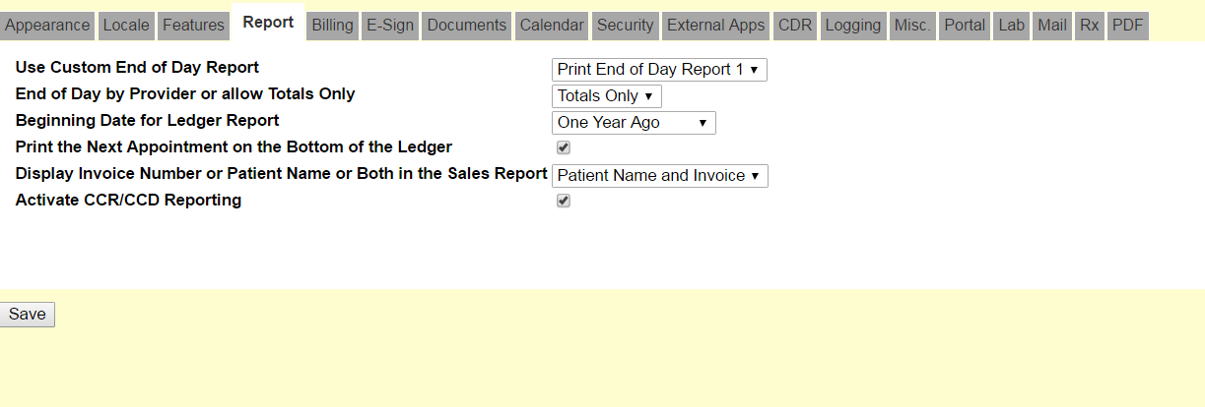Figure 1

The “Print the Next Appointment on the Bottom of the Ledger” when checked will place the next appointment at the bottom of the ledger printout.

The “Beginning Date for Ledger Report” is the default length of time for the report. The options are 2 Years, 1 Year, 6 Months, 3 Months, 1Month and 1 Day with the default being 1 Year. The user can set this option to 1Day and use it as a receipt for the patient.

The ledger is accessible under “Reports” options on the left hand navigation menu in figure 2 and on the patient demographics screen as shown below in figure 3.

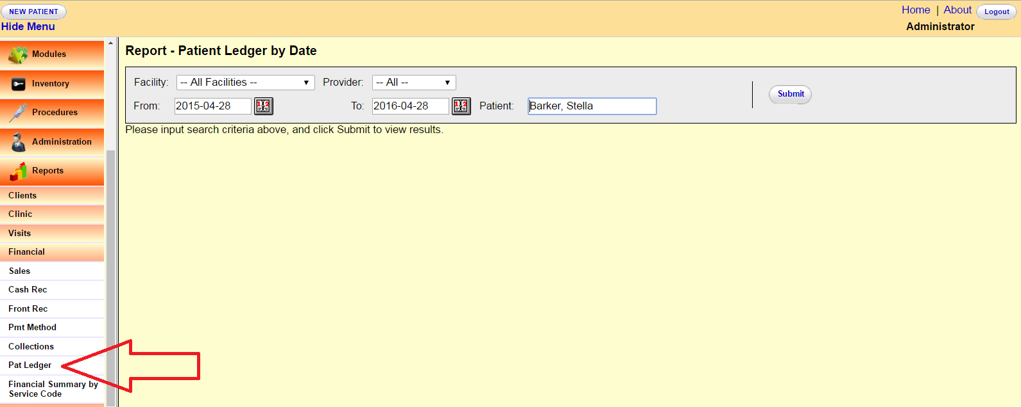 Figure 2

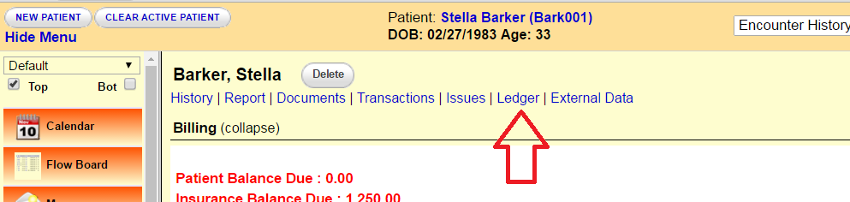Figure 3

